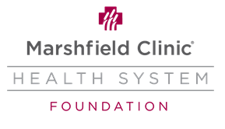
Marshfield Clinic Health System Foundation Gift/Pledge Commitment Form

I / We pledge $________________ in support of the Clinic’s research, education and patient care mission to be paid over ____ year(s). Pledges are payable for a period of one to five years.

Payment Options:

- Payroll deduction:
Ongoing deduction of $______ per pay period until paid in full.
Employee ID: ____________

- Pledge reminders:
Send reminders:  Annually  Semi-Annually  Quarterly
beginning on ____________________.

- Charge installments to my credit card.
❑ Annually  Semi-Annually  Quarterly  Monthly

Credit Card: (circle one) Visa MasterCard Discover American Express

_______________________________ ____________
Card Number Expiration date

Gift Designation:
❑ For the area of greatest need
❑ For the following purpose/fund:

Tribute Designation: (if applicable):
This gift/pledge is given in memory or in honor of

Please notify
Relationship
at the following address:

Donor Information:

Name(s) Phone

Address

City State ZIP

Email ______________________________________________________________________

Thank you for your pledge. Your support is greatly appreciated.

Signature Date

