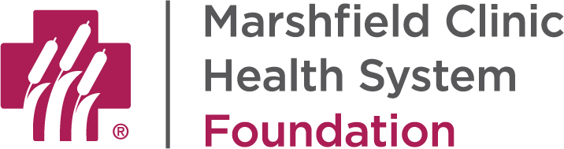

MARSHFIELD CLINIC HEALTH SYSTEM FOUNDATION
ESTATE GIFT OPTIONS

There are several ways in which you can support Marshfield Clinic Health System Foundation through your estate. Options include:

- Gift (bequest) in your will or trust. You can name Marshfield Clinic Health System Foundation among your family, friends and other charitable organizations to receive a set dollar amount or a percentage of the assets subject to the provisions of your will or trust. You would designate the use of your gift in addition to the amount or percentage. To illustrate, here is sample language:

I give $20,000 to Marshfield Clinic Health System Foundation, 1000 N. Oak Avenue, Marshfield, WI 54449, to be used for _______________ (state your desired purpose).

- Beneficiary designation on a bank account or certificate of deposit. Another option is to name Marshfield Clinic Health System Foundation as a beneficiary of an account you own. You would continue to be the account owner during your lifetime, with the balance of the account distributed to Marshfield Clinic Health System Foundation upon your passing. As with a bequest in a will or trust, you can designate the use of the funds.

One benefit of making a gift to Marshfield Clinic Health System Foundation through a beneficiary designation is that you can make that designation by visiting the financial institution where the account is held, versus visiting with your attorney to update your will or trust.

- Beneficiary designation on life insurance. If you have life insurance, you can name Marshfield Clinic Health System Foundation as a beneficiary. You would need to complete a new beneficiary designation form for the insurance company naming Marshfield Clinic Health System Foundation as either the sole beneficiary or one of several beneficiaries. Again you would want to designate on the beneficiary form (or otherwise in writing with us) the purpose for which the funds are to be used.

- Beneficiary designation on retirement plan assets. If you have an IRA or are part of a 401(k), 403(b), or other retirement account, you can name Marshfield Clinic Health System Foundation as a beneficiary of these assets. As with life insurance, you simply need to complete the beneficiary designation form and communicate with us the intended use of the funds.

Helpful tax information: If you are designating part of your estate to individuals (family or other loved ones) and part of your estate to charitable organizations like Marshfield Clinic Health System Foundation, you should consider making the charitable gifts from your retirement assets. While individuals pay taxes on dollars received from retirement accounts, charitable organizations do not. Therefore, it is best to give your individual beneficiaries other assets and use the retirement assets first to meet your charitable gift intentions.

- Gift of real estate with retained life estate. If you own real estate, another option for you is to give the real estate to Marshfield Clinic Health System Foundation, subject to your right to use the property for your lifetime. This gift is the only one of the gifts outlined in this letter which provides a current income tax deduction to you. However, the trade-off is that you cannot change your mind once you establish the life estate arrangement. If this is something of interest to you, we can talk further about it, including the steps Marshfield Clinic Health System Foundation would need to take before determining if we can accept your property.

Everyone who includes a gift in their estate to benefit Marshfield Clinic Health System Foundation is eligible for membership in the Doege Legacy Society. Please contact us for a membership form or to receive more information.

There are a few other types of gifts that can be made, including gifts that provide income to you during your lifetime. For example, a charitable gift annuity provides a set annual annuity payment to you for life, as well as a current income tax deduction. Gift illustrations can be provided upon request to understand how a gift would work for you based on your age and gift amount.

Contact Information:
Karen L. Piel, JD, CPA, CFRE
Charitable Gift Planning Officer
Marshfield Clinic Health System Foundation
1000 N. Oak Avenue
Marshfield, WI 54449
(800)858-5220 or (715)389-3868
piel.karen@marshfieldclinic.org

