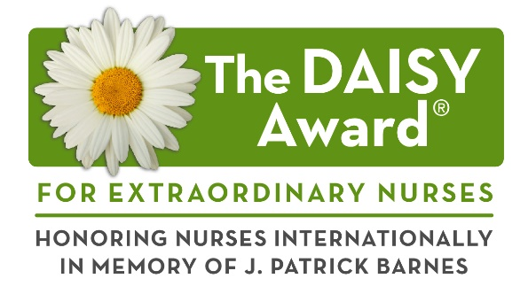

Nomination Form

What is The DAISY Award?
The DAISY Foundation was established in 1999 by the family of J. Patrick Barnes. Patrick died at the age of 33, from complications of the auto-immune disease Idiopathic Thrombocytopenic Purpura (ITP). During his eight-week hospital stay, his family was impressed by the care and compassion his nurses provided, not only to him but to everyone in the family. They created the DAISY Award in Pat’s memory to recognize those nurses who make a big difference in the lives of so many people.
Our DAISY Award honorees demonstrate excellence through their clinical expertise and compassionate care. They are recognized as role models in our nursing community. Marshfield Medical Center-Eau Claire is proud to be a DAISY Award partner and will recognize one of our nurses with this special honor every calendar quarter. Each DAISY Award Honoree will be recognized at a public ceremony in her/his unit, and will receive:
• a beautiful certificate
• a DAISY Award pin
• a hand-carved stone sculpture entitled A Healer’s Touch

To find out more about the DAISY program, including the growing list of Partners, please go to www.DAISYfoundation.org.

DAISY Award Nomination Form

I would like to nominate __________________________________________ from the_____________________ unit/department for The DAISY Award for Extraordinary Nurses.
Please describe a situation in which the nurse demonstrated at least one of these principles:
Applies exceptional interpersonal skills with patients, families, peers, and colleagues.
Demonstrates extraordinary care to patients and families through development of mutual trust, respect, and emotional support.
Has created a sense of family.
Generates enthusiasm and energy in nursing.
Listens with their heart
Pleases share a story involving the nurse you are nominating that clearly demonstrates how he/she meets the criteria for The DAISY Award:
______________________________________________________________________________________________________________________________________________________________________________________________________________________________________________________________________________________________________________________________________________________________
Thank you for taking the time to nominate this extraordinary nurse. Please tell us about yourself, so that we can include you in the award celebration if your nominee is chosen.
Date of Nomination _________
Your Name _________________________________________ Phone ___________________
Address _____________________________________ City___________________________
State____________ Zip_________________ Email __________________________________
I am (please check one): Patient Family/Visitor Volunteer Staff

How to Nominate an Extraordinary Nurse
Patients, families, visitors, nurses, physicians, and other employees may fill out this nomination form and deposit the completed form into the DAISY Award Nomination Boxes located on the 4th floor nursing unit, the foyer of Marshfield Medical Center Eau Claire Clinic, or at the entrance to the Bistro.
You can also submit the form by mail or e-mail to:
Nursing Administration
Attn: Richard Schahczinski, RN
Marshfield Medical Center-Eau Claire
2310 Craig Rd.
Eau Claire, WI. 54701
or
E-Mail to
Schahczinski.richard@marshfieldclinic.org

(Additional comment space if needed):
_________________________________________________________________________________________________________________________________________________________________________________________________________________________________________________________________________________________________________________________________________________________________________________________________________________________________________________________________________________________________________________________________________________________________________________________________________________________________________________________________________________________________________________________________________________________________________________________________________________________________________________________________________________________________________________________________________________________________________________________________________________________________________________________________________________________________________________________________________________________________________________________________________________

